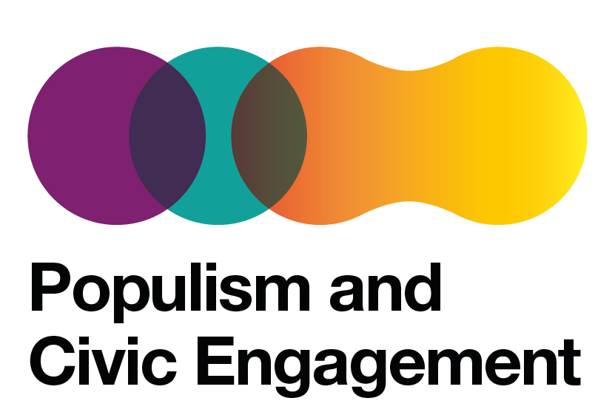
Populism and Civic Engagement Conferene, 15-19 November 2021

We are delighted to invite you to a conference summarising three years of our research work in the Populism and Civic Engagement (PaCE) project, carried out within the Horizon 2020 research and innovation programme.

In this event, we aim to present findings from the research carried out by the PaCE consortium partner institutions and, together with participants and stakeholders, develop the approaches to connect research with policy-making. PaCE conference is a hybrid event, divided into two parts:
- Expert roundtables - 15 November, 12:00-18:00, Residence Palace, Brussels
In-person sessions run by PaCE leaders with the invited stakeholders: policy experts, civil servants, journalists, academics, civil society representatives.
- Seminars - 17-18 November, online
Open online webinars and workshops run by the PaCE researchers.
Please see the full agenda and register through this link: -> https://pace-conference.b2match.io/

We'll be happy to answer any questions you might have. Please get in touch with us at pace@demsoc.org.

